UNIVERSITY OF PETROLEUM & ENERGY STUDIES

SCHOOL OF COMPUTER SCIENCE

A Project Report of 3D-Model of Living Room in Blender 2.8

Submitted To, Submitted By,
Dr. Durgansh Sharma Rahul Raj Baranwal
Associate Professor SAP ID 500061624
Department of Cybernetics Roll No- R100217054

Abstract:

Blender is the free and open source 3D creation suite. It supports the entirety of the 3D pipeline—modeling, rigging, animation, simulation, rendering, compositing and motion tracking, even video editing and game creation. Advanced users employ Blender’s API for Python scripting to customize the application and write specialized tools; often these are included in Blender’s future releases. Blender is well suited to individuals and small studios who benefit from its unified pipeline and responsive development process.
Blender is cross-platform and runs equally well on Linux, Windows, and Macintosh computers. Its interface uses OpenGL to provide a consistent experience. To confirm specific compatibility, the list of supported platforms indicates those regularly tested by the development team.
As a community-driven project under the GNU General Public License (GPL), the public is empowered to make small and large changes to the code base, which leads to new features, responsive bug fixes, and better usability. Blender has no price tag, but you can invest, participate, and help to advance a powerful collaborative tool: Blender is your own 3D software.

Problem Statement:
In this project, we will create a 3D model of a living room using Blender, we will create all kinds of 3D structure inside it, like couch, table, books, flower vase, and floor rug. We will model complete house with porch area along with chairs and basic boundary of house.

Steps to create the 3D-Model:

Step-1 We will start with couch and TV and something we'll make a little living room out of it and I'll try to recreate the ambience of the scene and the lighting and all that stuff so you get some value out of it let's get to it and let's create some living room let's jump into the new blender file first of all we'll need to create some space to define the boundaries of the living room so I'll just press shift a and add a plane and we can scale this four times so press s and 4 enter and right now we can just go to the edge select mode by pressing to select these two edges right there and extrude the walls so let's press E then Z to lock this and extrude and I think something will like 5 will be enough so this will be our room and maybe give it some thickness so let's press a alt a to extrude and extrude along normals like this and if you press s you can scale this evenly and let's just enter a point 3 on the keyboard and - to go to the other direction let's press ENTER so this is the base for our room I want to create a sofa here they'll be like a main object for the scene I want to focus on so let's step out and shift right click here to move the cursor let's press shift a again create the plane and right

Step-2 Now we want to scale this into a size of a couch so something like this I want I want this couch to be a little bit bigger here because I really want to do just the small scale room not the full scene like I'm used to so something like this will work probably and we can now press G Z and move this up in the edit mode a little bit so there's a empty room down there where the legs will go like this and right now we can press E and extrude this like that additionally we'll need some loop cuts to continue so let's press ctrl R and let's add some more loops with mouse wheel and confirm and we can now release this by clicking the right mouse button and let's scale this on x-axis so s and X and scale this right here and add one additional loop cut right here and move this to the back like that right now we can go to the face select by pressing 3 click this face and by holding ctrl we can head to the selection and right now we can just press E and X to this even more like this maybe not so much so it's gene and Z and right now we can select only these two in the back and extrude them up like that so this will be base for our couch

Step-3 Now we can give it some smoothness so let's step out and add a subdivision surface modifier or just press control two to enable it and you can see there's some work to do right there so first of all I want to enable smooth shading so right click and click it smooth like that and let's go to the edit mode press ctrl R and add some loops here so I want to add a loop here loop here and you can notice how the resulting mesh from the subdivision modifier changes when you add some more loops like this don't go all the way leave some space there so it's not too sharp and you can modify it like that so I think this will be quite okay maybe we can add some more loop here and one here to make these corners here nice and round so if you type out this will be a nice base for our couch and right now the only thing missing is some cushions so what should right click there restrict a and add a plane right now we need to scale this a little bit so scale these on the y-axis press s then Y scale and has an X scale this like that and extrude so this will make for a nice cushion right there and here I want to add some cuts so let's first control our something like yeah three cuts will be enough I think and two cuts maybe more three cuts right here and right now if you go to the edge select and alt click this loop and alt shift click this loop you can scale them out like that and I'll click this and alt shift click this and scale these out like that and I didn't want to subdivide because I didn't want to add any geometry on the z-axis here just yet because I wanted to have more faces on on the top side here because right now I want you to go to the face select by pressing 3 but select this 4 and there's nice little function if you press right click and poke faces you will create these vertices here in the middle of these faces and we can work around that so right now let's just type out of the edit mode and press control to to enable the subdivision surface you can check it in the modifiers here you can see there is a subdivision modifier right there.
Step-4 Now, right click and sheet smooth and right now you can either start moving these right away so let's press G and z and move them down to create this uneven surface and we can now below this so let's press control B and you will see anything will happen but if you press V additionally you will enable vertex only mode and let's switch these two individual origins and let's scale those X a little bit that and right now we can move them down a little bit and if you press ctrl + u will expand the selection and you can move the whole thing a little bit up so we have a nice cushion right there and now we can just duplicate this so all D and X to duplicate this on x-axis and maybe select them bolt and move them about a little bit we don't need to be precise with this so I think this will work nicely ok we can now make smaller cushions and I don't want to duplicate this because there are 4 for these holes right there and I won't only want and I only want two of those on the smaller cushions so let's just shift right click here and create a plane again let's scale this down something like this scale on the X and extrude and once again we'll repeat the process so right now I want only two cuts here let's press s and Y to scale it here and

Step-5 We can do three cuts like before here and then alt click here alt shift click here and scale this on X like that and we can poke these two so right click poke faces let's double Ds control B than V or ctrl shift B whatever you like then press G Z and move this down and again we can press ctrl+ to expand the selection and move this up like that let's step out and let's press ctrl to right click and shade smooth so there'll be our smaller we can now look from the side by pressing three or by holding tilde key and selecting right if you want to see your object a closed or center your view you can always use the tilde key and bu selected or the period on the numpad whatever you prefer so right

Step-6 Now, let's go to the side view rotate this and all this here okay and now press G then X move it here let's look from the front by pressing number one press all the X here and again all to the X and move it here we can now scale this again we don't have to worry about any precision right here and right now I want to duplicate these so all day move it here let's press alt-R to reset the rotation then R and Z and92 rotated 90 degrees let's look from the side we can move it here from the top so I want to create like small side cushions right there something like this and right now we can out the X and move it here so yeah this will be our sofa and one last thing in mrs. are the like undrneath but they'll be very easy to do so let's just select our base object for the sofa and you can see the origin point is right there on the bottom so it’s easily scaled up and down on the floor as you wish so let's press shift sto snap and cursor to select it right now we can press shift K and add circle object and we can modify the number of vertices I like something like 24 let's dive in what scale this down press F to fill this seven for the top view Holsey and switch to the wireframe view right now we can move this underneath our couch like this and press s to scale it down okay let's look from the front by pressing number one and let's press E and extrude this up like that and we want to babble this a little bit so let's go to the edge select let's press control B and double it maybe two segments you can control this by mouse wheel stop like that and bottom one -okay we can go to the solid view and enable sheet smoothing like that right now since we move this into the corner but the origin point state in the middle because we moved it in the edit mode not the object mode be careful about that you can add the mirror modifier right here and check X&Y so you have four likes so this our sofa

Step-7 Now, we can select all and control drag here tithe select the room object shift select the main object press ctrl P and pair into object and keep the transformation so right now we have the sofa object that’s parented and we can scale this up and down on the floor and move it about Solet’s press our rotate it 180 degrees and this will be our base for the Livingroom sofa right now I want to add some TV screen right here some little table underneath some picture frame there and maybe something in the corner or some plant really just a few objects to fill this a little bit and then play with the lighting and render it out so it doesn’t take so much time we can now move the cursor on the wall here so shift right click here let's add a plane so shift plane going to the edit mode let's press our X and rotate this 90 degrees let’s scale this on X if you want you can be really precise and check your particular proportions herein the item when you press n you will see the sidebar and you can set your dimensions right here like 16 to 9 proportions of TV flat-screen or something like that I I won’t be worrying about that right now so so let's just jump right back in and now I want to close this I'm going to BLM ode I want to keep the origin Pointon the wall here so let's press G and Y and move this a little bit out let's make this smaller let's extrude this large something like this and extrude once more we can now insert this and extrude inside a little bit and if you want you can solve this face right here the small ones of those three and select this with the face and you can move it up a little bit if you want to have like a larger space here under need if you want to have some LEDs hero some lights or something whatever you need and right now since this will not be a detailed object we won't need to use the subdivision surface modifier we’ll just use some bevels and smote reading so let's just go into the face select by pressing 3 alt click this loop right here and let's battle this a little bit and I think two cuts will be fine like that and this is just for some curvature to be there when you're faraway and the light hits the object you will see some nice reflection when you have a smooth shading enabled and as you can see the smooth shading doesn't looks well on a large faces like this so we’ll need to do some additional bevels so I'll click the loop right here and let’s bevel that with just one segment like this and then what's like the inside face this and let's battle shoutouts likely okay I think this will do nicely for a TV

Step-8 TV, let's move this in place a little bit better so closer to the wall you don't have to touch it really and you don't have to do any like device for hanging these on the wall it will be totally covered so just leave there a little bit space and maybe later we can do some ambient lighting behind that TV screen or something like that and I think we can make this much larger since this is just kind of a micro roomer something like that and I really miss some furniture here so let's press shift right click press shift a add a plane sand Y scale this make this wider something like this we can move it up a little bit then extrude that click the face right here is I to inset and extrude inside and of course we can double this a little bit and you can doit with a balloon modifier as well so let's do that let's add two segments and by holding shift we can collapse this a little bit and the smooth shading there so it looks much better yeah and right now we need to add some lights there as well so let's go shoot a and we'll add playing game on top view I will hold Z and go to the wireframe view tap into the edit mode and scale this down OH into the corner again and the same and the same stuff applies that with the couch so let's go to the front and through this and I won't do any bubbles there it will be hardly visible but I wanted to have to have it there so let’s just add a modifier and check the Y and think this is ready we can now just parent this so shift-click the object let’s burn this and right now the last thing I want to do here is to add some picture on the wall so let's first shift right click and again it gets to right we can just rotate it on the Y 90 degrees and let's scale this like that and maybe they'll be enough or maybe let’s delete this and I will do something different there so I think this will do as a base for our room
Step-9 We can now go to some texturing and adding some materials and we'll see how it goes let's switch to the shading tab and right here we'll start with the room and we’ll add some planks on the floor so first of all let's select the room object or center on the object go to the material tab and right here I want to add a new material and let's call this wall and I want you can leave it wide I want something like this a little bit orange to it just like that so everything has the wall material and right now we can add a new one and let's call the floor and just tap into this slug the face and apply and assign the floor material there and right now here in the node editor we can import some PBR textures here and you can get a lot of cc0license PBR textures out there if you go to the textures one or a side like that you will find all the links in the description I will link all the textures there all the materials all the sources mentioned in this video so so you can find all of that in the description and after downloading these you can navigate here in your folder and we can see we have some wood planks there and there are bunch of different textures but were interested only in three of those and that's the diffuse the normal and some roughness map or something like that I don't know which one it is right here but we'll find out so first of all you can just click and drag this into the scene like that and connect this to the base color and you can see there’s already texture applied so right now we can just drag normal map into the scene but don't forget to switch the color space to non-color data because we’re not using color from this texture right here we can press shift a and add vector normal map connect the color right here and normal into normal output or rather normal input so there'll be our normal map and right now we can import the roughness so let me switch these two horizontal list so we'll see what we have here and here is thoroughness channel take that and drag it into the scene and again we want to switch this to non-color color space and connect this to a roughness channel right there and sometimes these are inverted so if you look like this you will see this is too much of a gloss in my opinion so what you can do is press shift a and invert this it'll make completely rough but then you can play with the factor of the inversion and find the roughness you want and you still have like a non uniform roughness texture there so that's quite useful maybe we can reduce this even more like that okay and if you think the texture is too large here you can either scale this manually in the UE editing mode so you can grab this and scale it around or you can go to the shading and click the texture and press ctrl T but they’ll only work when you have a node Wrangler enabled so go to the add-ons enable nontriangular and right here if you press CTRL T and a texture you will get this texture coordinate and mapping node and the best thing is you can connect this to multiple textures like that and have one scaling for all of those so that’s like this and maybe scaled is too- like that and I liked it was quite large so let's do 1.5it'll be great I think okay so that’s the floor for you.

Step-10 Now we can continue the couch will be really simple don't want to add any textures there so let's just create a new material let’s call this sofa or you can call it either or whatever you like and let’s give it some dark color maybe like dark gray and will reduce the roughness a little bit something like point four will be fine and I want to add these tall those questions and if you have filling duplicate it will apply to all of those automatically and then I want to add this here as well and we can I think these are too large so maybe we can press a to select all as shift Z to lock this and make them a little bit more slender okay like that and I would really like some aluminum feel or something like that to it so let’s create a metal material and let's bring the metallic all the way up and let’s relieve and let's leave roughness hello can talk today let’s leave roughness 0.5 so it's that nice little it's that nice brushed metal look right now we can move to the furniture there so let's focus on that let’s create a new material let's call it would and again I've downloaded some wood material here so let me show you and again you will find a link in the description right now I will do the same thing I will drag all of those maps here and the second thing we'll need to do is to unwrap this somehow but I will do this very quickly just go into the edit mode let's select all Brazil to unwrap and let's like smartly we project everything I want to do right here I think the blender does nice job by automatically unwrapping if you would like to have process control over the flow you can always do this manually But i don't want to go into that right now and here we can do the same thing for these so we can just selected material we can see those as smartly we project like that and right now let's just add some black material to the TV and we can give it some glossiness so let's reduce roughness to something like point two they'll do nicely.

Step-11 I want to replace the screen after this so the next thing I want to do is to add that picture on the wall and I’ve downloaded this abstract picture I found it on the pixel count which is another amazing site for image downloads there are CC zero so you can find it there or following in the description and right here we can just press shift eight and we have still the cursor on the wall there so we can press shift 8 go to the image and images and place images as planes if you for some reason don't seethes here maybe you have to enable atom for that so if you don't have it here go to the add-ons preferences add-ons and search for images as planes and an ID with that right now we can just click that locate the picture and import it here and if we zoom in you can see there’s a plane imported with that picture and there's already a material created for that so this is where how to easily import images with the correct proportions into the scene so let's now just rotate this so our X 90 our Y Z 90 like that scale this up okay I really like this movie wall a little bit then we can just press E and extrude this a little bit not too much and I really don't mind these things on the side the bleed of the texture so yeah it's quite nice and right now we can import that TV screens that's like that we have already the correct face selected so let's create a new material let's call it TV click assign right now let's just import that image and so we have the texture right here we can now connect this but I want to do this as a machine shader so let's select this principal trader press X to delete this let’s brush it a go to the shader and add a mission shader right here connect this and connect the image right there and right now we can go to the Subediting again and again we can just press Q to unwrap it's the scene and we can move this in place just like that let’s save the file and if we now go to the shading you can see this looks great we can maybe bring up the brightness of the emission okay so um this is it so let's just finish up with some lighting.

Step-12 We can now switch to the material preview and go here and enable scene lights and scene world so we actually see what's happening there I want to make this a little bit bigger maybe and move this so G and shift X to move it only on the X only what only on y&z plane like that okay and maybe I want to do this a little bit higher sure 30.5yeah I think it will look better I don’t if it's a little bit higher okay so type out move the TV move it up and we cannot make this a little bit larger okay and I use amazing add-on I so can you can find a link in the description there’s an update so it works with the blender 2.8 so yeah let's just click the game I so cam it'll create isometric camera for you and right now we can move this a little bit up so GD + Z by holding ctrl + shift we can position it and right now just change the resolution always go for 4 to 3 ratio because I post my images to dribble so that's my like default resolution I render with and right now we can go to the camera settings and change this to something like 16 or - graphic scale so we see better what's going on because in the ultra graphic mode moving camera in and out won't help you one little bit right now we can reset the cursor so press shift s cursor to world origin let’s brush it a at the plane tab Ian and scale this out so we are out of bounds and right now we can go to the front view and move this a little bit down so press G then Z and move this right here so I always like to do this backdrop for my isometric scenes and right now we can add some light so let’s shift a white area move this up suppress Z move this up switch to the 3d cursor or go here and switch there press our X45 minus RZ 45 so we get this nice angle directly opposite of the camera and now we can make this a little bit larger and let’s ramp it up to something like 1500 okay and let's create a material here for the background let's call DG and let’s tone it down or we can maybe make blue but I think the dark the black will do for now and I want to select the right here and give it some blue color so it sets the tone for the scene a little bit like that right now we can go to the world settings and bring some ambience in the mix so let's click here and add some blue color to fill the shadows

Step-13 We can drag this down a little bit right now so it's not too much hey let's add another light or we can duplicate this one so let's press shift D enter our Z and rotate it like that and then R and X twice to rotate it like that maybe we can move it up on the z axis a little bit make it larger press G Z twice to move it a little bit backwards and I want this to be more subtle so let's to help with that something like 750 or even only 500 and want more blue in that so we’re basically just doing some basic three-point lighting and for this isometric scenes there are a bunch of ways how you can go about lighting you can I close this with a transparent roof and make some really realistic lighting inside without the lighting from the outside or you can have light coming in just to the window or something like that but right here I want to do some basic lighting so let's press shift t Rotate is on the other side here we can maybe change the color a little bit so you can go like orange here and maybe it’s light coming from the kitchen or something and one more thing I wanted to do is to do some ambience behind the TV so we can either have some area light there or maybe some point light or we can select the TV let's isolate it with the slides on a numpad let's type in select this one here creating your material let’s call this backlight and let's switch this to emission let's assign and let’s give it some nice silent color with a little bit more strength like that and here you won't see nothing because we are in the eb mode but if you go to the camera let's drag a boundary around the camera so control B so we don't have to render anything outside of that and let’s switch these two cycles slowly switch to GPU and let's preview this render mode that so you see we have some nice ambience there but it might be too much I think so let's tone this down to10 okay we have some nice light going from the TV we can maybe try run that up think they'll be too much so 2.5.
Step-14 Let’s go to material preview and we can add a spotlight to this art so it has like own cool lighting or something so it’s pushing a light spot and bring this up like this we can wrap this 550 and blend it a little bit so but just blend that and maybe of this here and rotate and rotate on the Y but let me switch back to the median point is our Y rotate this I think this was enough okay and if we now go low to the render preview I think it adds a nice little touch to that and the last thing missing are some objects some details here because this looks too dull there’s nothing here basically so you want toad something to the scene maybe just books or something like that so yeah we can do that that they'll be quite easy so let's add a plane let’s resize that extrude then we can Sothis is all II as extrude or normal CTRL + + we can add a new material here what’s called a white and let's add another one let's call that book okay let's change the color and a sign okay maybe we can make it a little bit darker and right now we can select this loop and extrude it as well so I think this will be enough for a book we can maybe this up a little bit in the remote so the pivot point is there on the bottom so we can easily scale this rotate and maybe we can alter the duplicate down let’s look like that then move it here scale on the Z make maybe larger LD create another one scale it on Z again maybe add another one okay like this to the side so you get my point just to create some visual interest there and you can maybe let’s split this from the linked duplicates and like let's make this another colors I will duplicate this book material and maybe do the red color or something okay and you could go and add and other details so I will maybe to that later but basically this is the finished scene you can add something like remote-control or something like a gaming console PlayStation gaming controller you can have a guitar in the corner and right now I would really like to play with that world ambience I think now when the lighting is in place we can add some blue light to the mix and I think it looks really nice after rendering your scene you might notice there’s quite a bit of noise in the scene mostly when you use the emission lighting so if you want to get rid of that you will need some kind of the noising.

Output Images (Rendered):
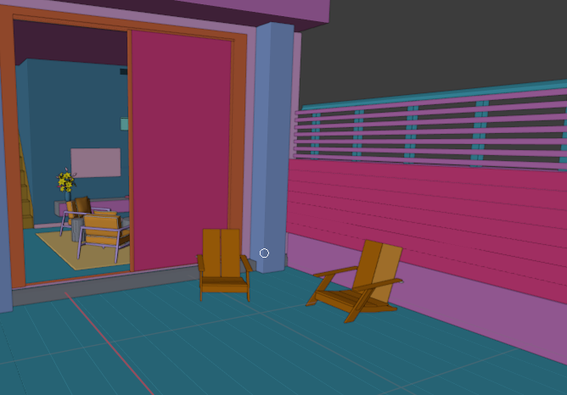

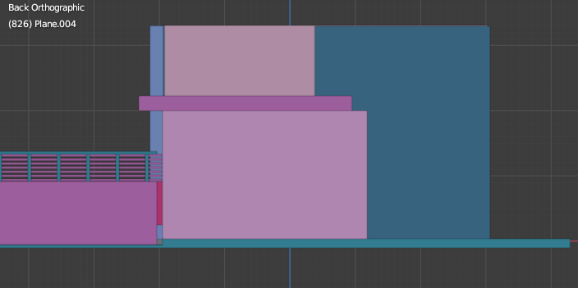

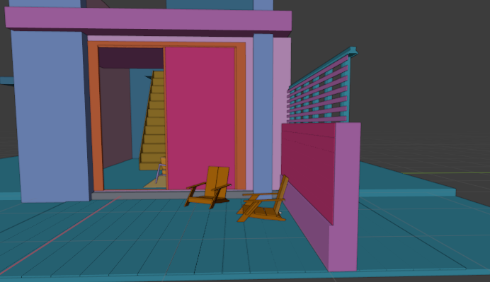

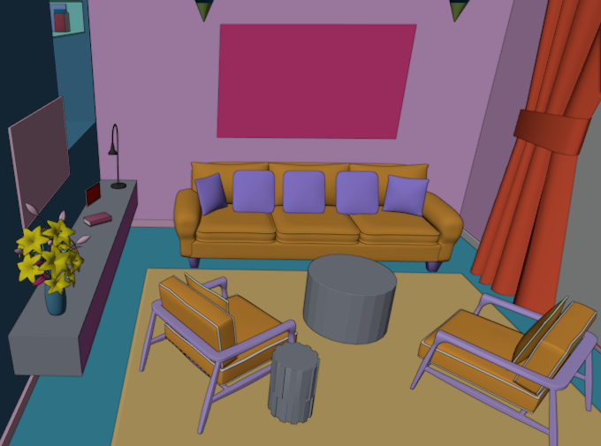

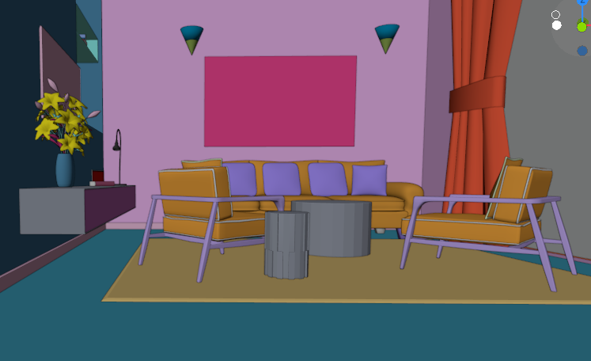

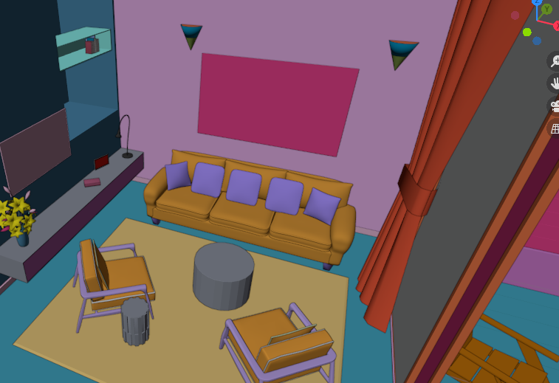

Drive Link:
https://drive.google.com/drive/folders/1gn8jf23otG3q2guqTqu_dEoAsUp7hiID

